## Progress Update: Report on the status of the survey analysis.

We have done some initial exploration of the results but have not yet completed analyses since the data collection process is still underway. There will be two largely parallel analyses done for the Pennsylvania and adjacent state samples. Given the complexity of the survey results, they will be analyzed initially into six sections:

1. Demographics (including current and prior living status)
2. Place attachment and place preference
3. Relocation (moving) perceptions
4. Push and pull factors
5. Affective imagery study
6. Discrete choice experiment (policy proposal experiment)

Both samples may further be stratified for analysis (time pending) into “rural” or “not rural” based on their response to the current living status question.

## Progress update: Report on and summarize preliminary research findings to date.

Below are preliminary results of the adjacent state sample for Demographics (section 1), Place Attachment and Place Preference (section 2), Push and Pull Factors (section 4), and Affective Imagery Study (section 5).

### 1) Demographics

The adjacent state sample consists of respondents from all 10 states that were targeted. The distribution is largely reflective of the population across states, except for an over representation from Connecticut and under representation from New Jersey and Massachusetts.

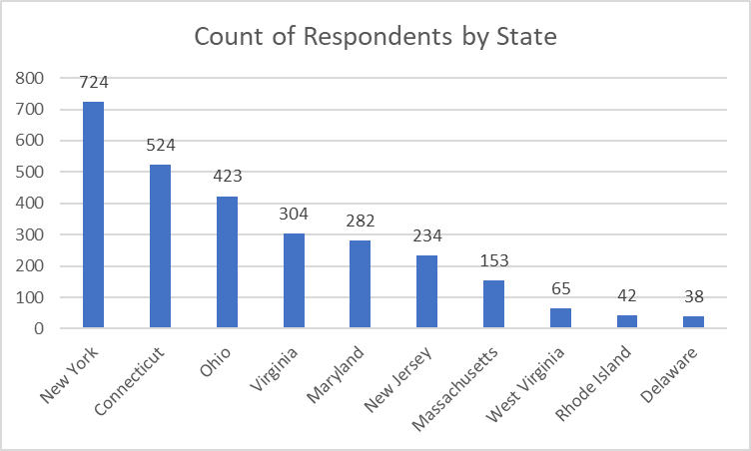

Within-state distributions covered a range of counties and don’t appear to be abnormally concentrated in any one part of the state (e.g., about 20% of New York residents were from New York City).

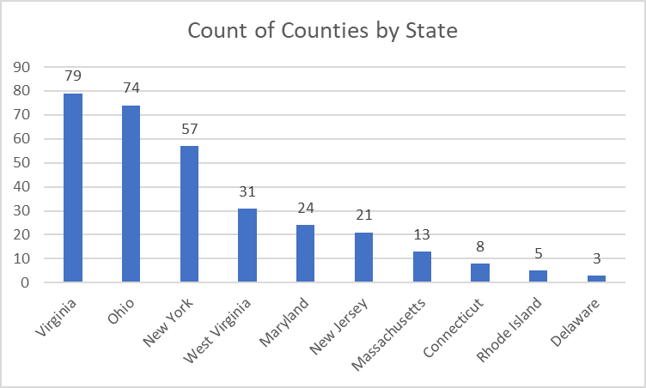

About a third of respondents currently live in a big city (35%), followed by suburb of a big city (20%). However, 62% indicated they have previously lived in a rural area and 42% previously lived in a rural area in Pennsylvania.

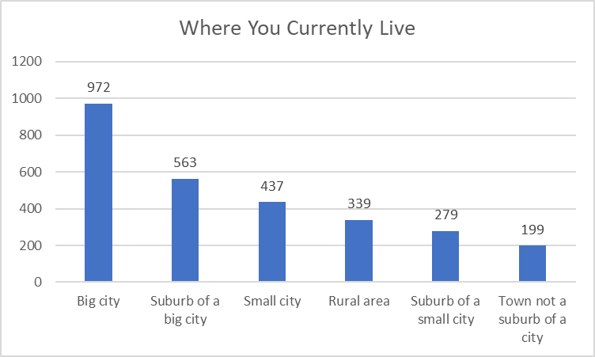

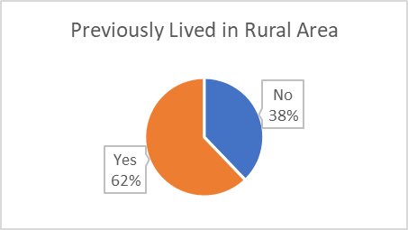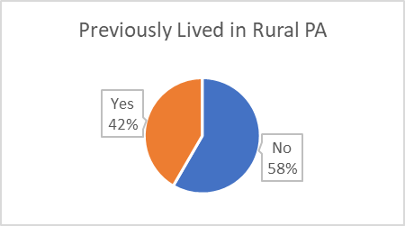

The most prominent demographic categories for respondents in the sample included:

* Gender - Female (51%)
* Race/Ethnicity - Caucasian (77%)
* Education - Holds a bachelor’s degree (56%)
* Marital status - Married (67%)
* Household size (including self) - four (30%)
* School-aged Children in Household - None (39%)
* Rent/Own – Rent (42%); Own w/ Mortgage (41%)
* Annual Household Income - $50,000-$74,999 (29%)
* Student Loan Debt - $0 (27%)
* Political Party Affiliation – Democrat (55%)
* Political Views – Conservative (23%), Liberal (23%), Moderate (23%)
* Employment Status – Working, paid employee (70%)
* Type of Job – Private-for-profit company (57%)
* Job Location – Office, home or employer (50%)
* Remote Work Status – I work remotely from anywhere I choose (33%)

The full distribution details are provided in the charts below.

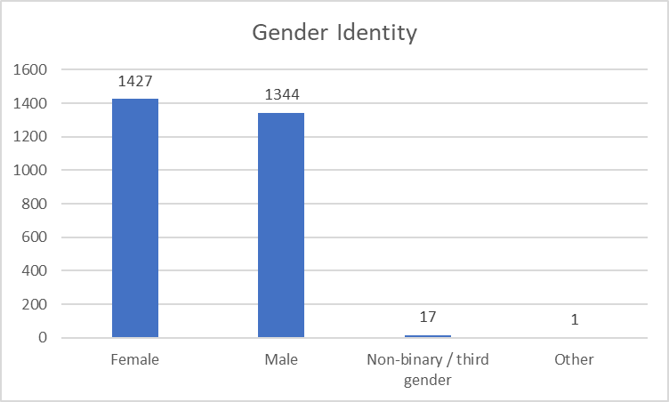

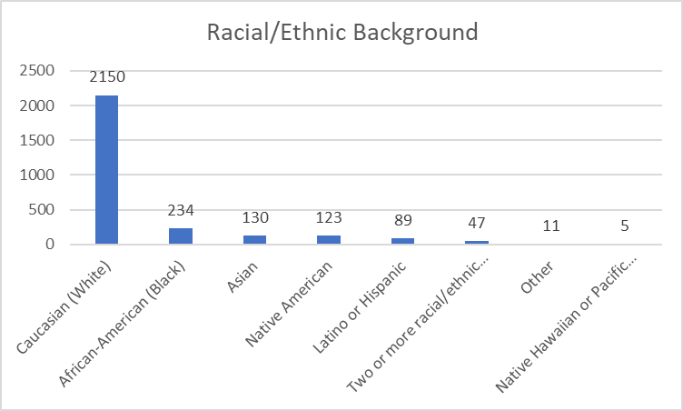

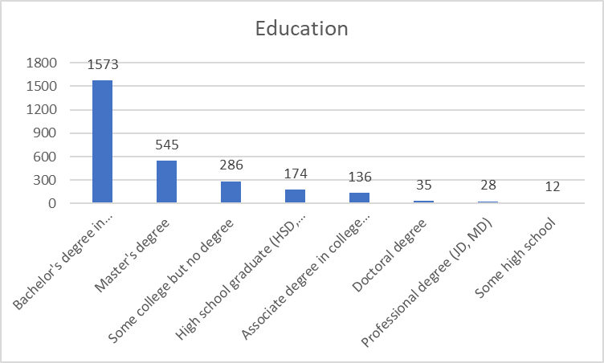

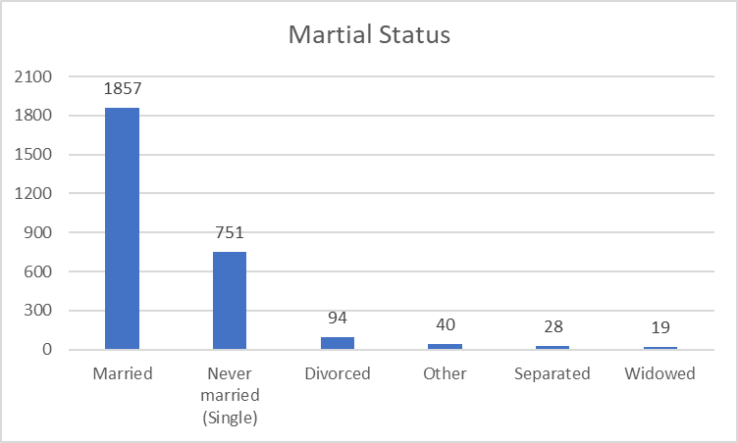

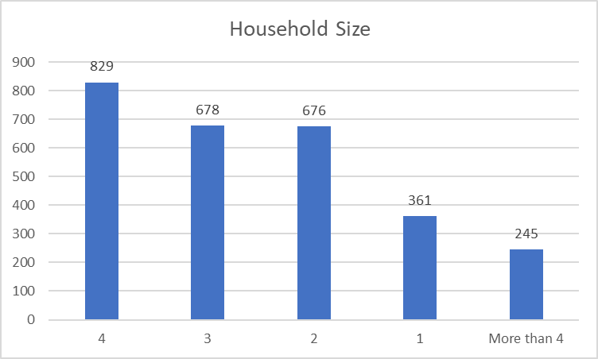

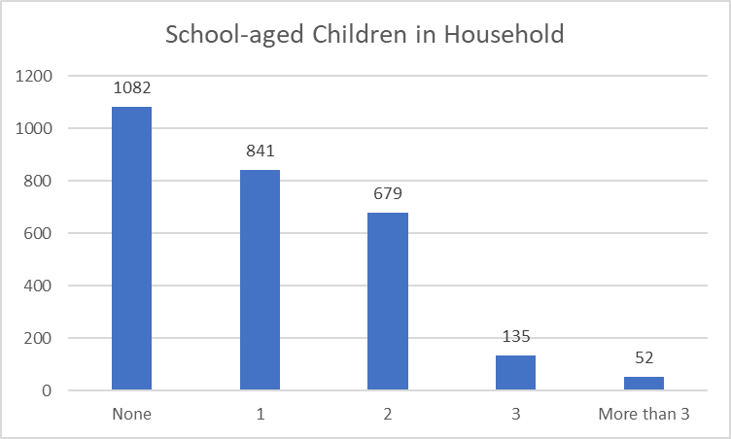

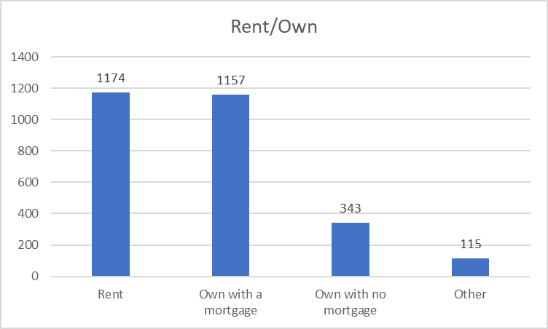

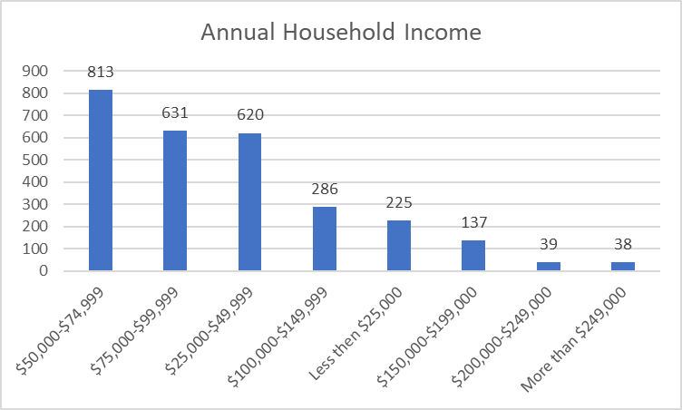

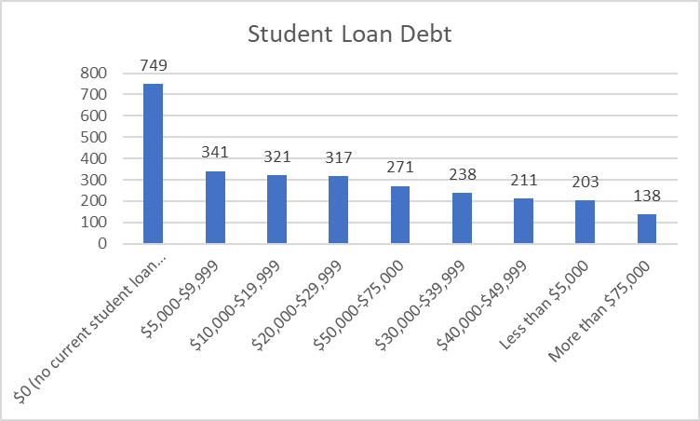

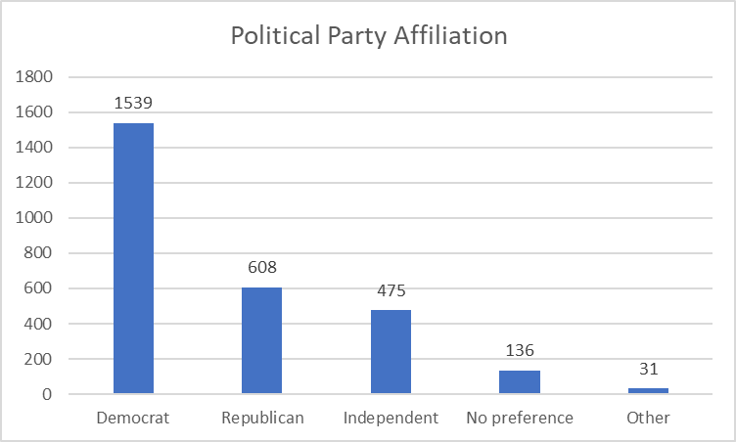

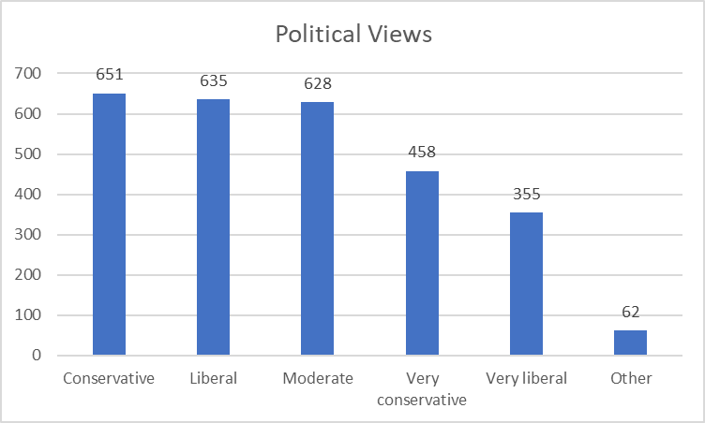

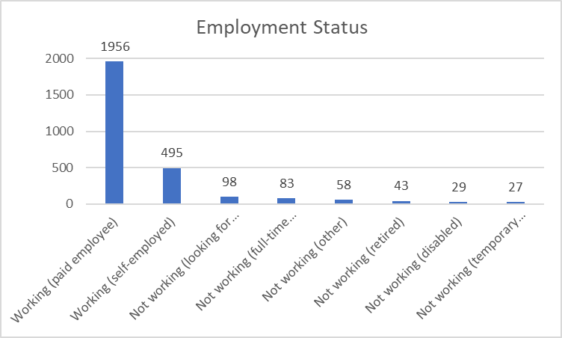

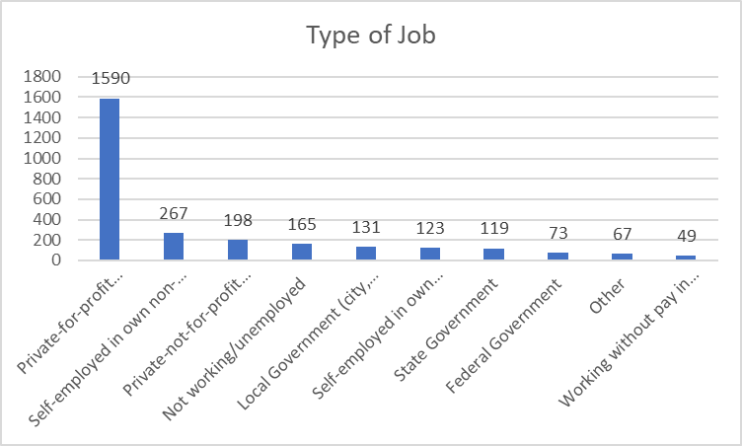

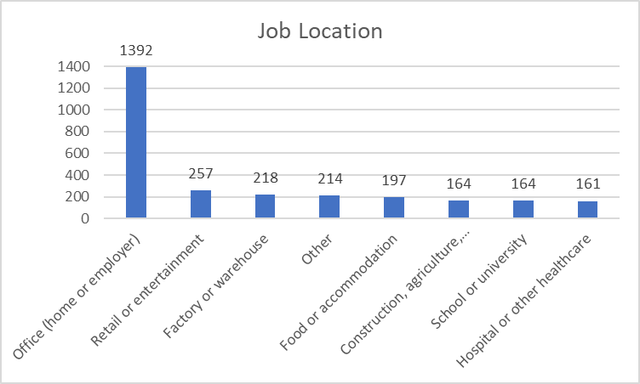

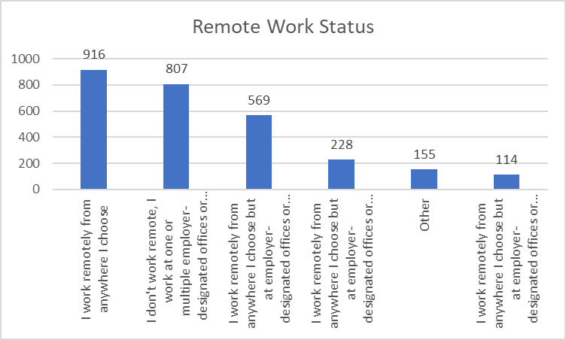

### 2) Place Attachment and Preference

Respondents largely demonstrated a strong attachment to where they currently live, with 75% of respondents agreeing in some capacity to both having a strong sense of belonging and feeling emotionally attached. Sentiment was less affirmative when asked about moving away, others moving away, or both moving away from where they currently live, but roughly two-thirds of respondents agreed in some capacity to those three items. Initial reactions suggest that attachment is high, but several respondents may be open to moving.

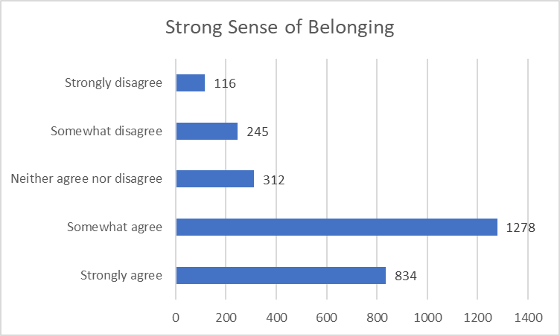

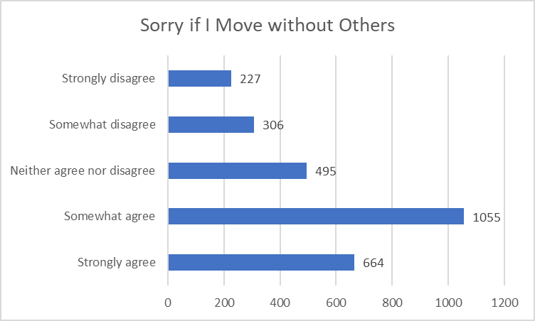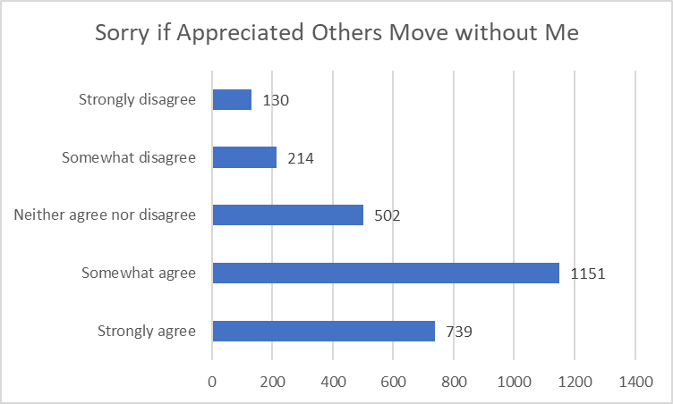

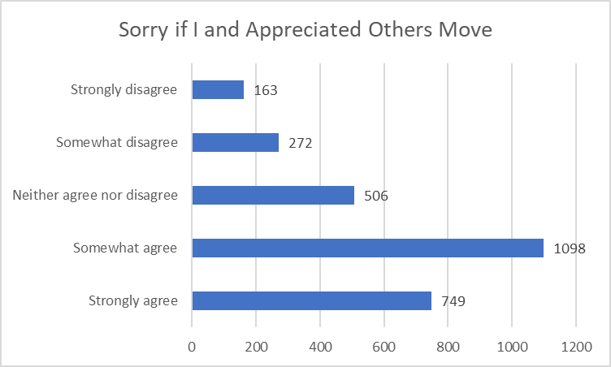

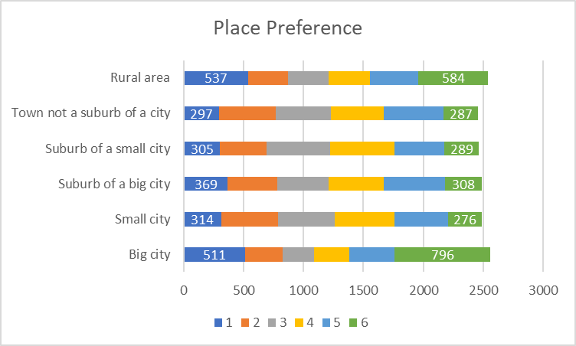

The sample demonstrated a wide variability in terms of place preference (i.e., “If you could live anywhere you wished, where would you prefer to live?”) and may demonstrate a mismatch in where respondents live when coupled with place attachment and current living status (planned future analysis). “Rural area” received the most first choice rank (i.e., 1) but “Big city” was a close second, and the remaining four choices were similar in first choice ranks (see dark blue band in the chart below). “Big city” received the most last choice rank (i.e., 6), and “rural area” was a further distant second (see green band in the chart below).

### 4) Push and Pull Factors

The 21 “push and pull” factors (i.e., things that draw or detract individuals to living in a rural area) that were assessed all largely leaned towards being affirmative, even with using a 7-point Likert scale. In other words, nearly two-thirds of respondents agreed in some capacity that they “needed” each of the 21 factors, with the lowest level of agreement being found for access to higher education (65%) and access to long-term care (65%). Highest level of agreement was found with access to broadband (88%), access to healthcare (86%), and supports need of family (86%). When looking at the full 7-point Likert scale, access to broadband still topped the most “strongly agree” (39%), however opportunities for civic engagement had the least level of strongly agree (14%).









### 5) Affective Imagery

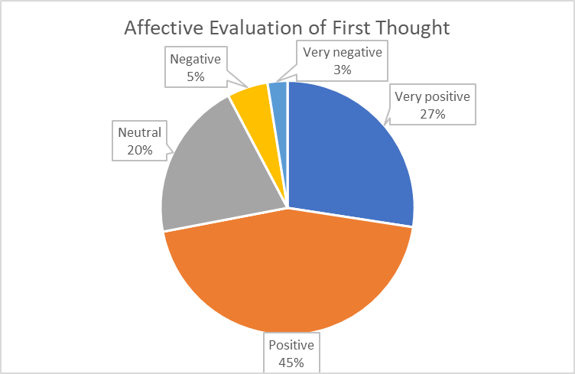We are currently determining the coding scheme to be used for this analysis. Based on the preliminary analysis of the first question in this section (i.e., First thought or image that comes to your mind when you think of "rural Pennsylvania"), the responses are extremely wide ranging in terms of both structure and content. Regarding structure, the responses are wide-ranging nouns (e.g., “Amish”, “dunder mifflin”), basic adjectives (e.g., “nice”, “backwards”, “silent”, “flat”), and complex phrases (e.g., “different from Phil and Pitt”). This complicates the analysis and requires thoroughly combing of all responses. For content, initial patterns/themes have emerged that will likely be prominent once the analysis is complete – these include themes of landscape (e.g., mountains, fields, forests), agriculture/farming, and mentioning specific locations. The affective evaluations of the first thought lean heavily positive (see pie chart below).